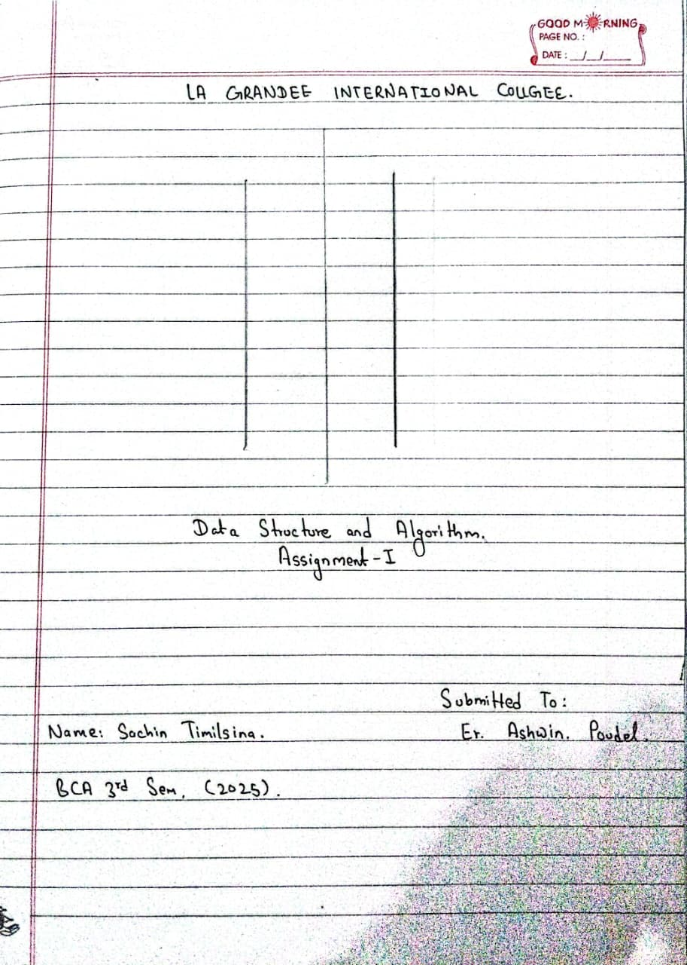
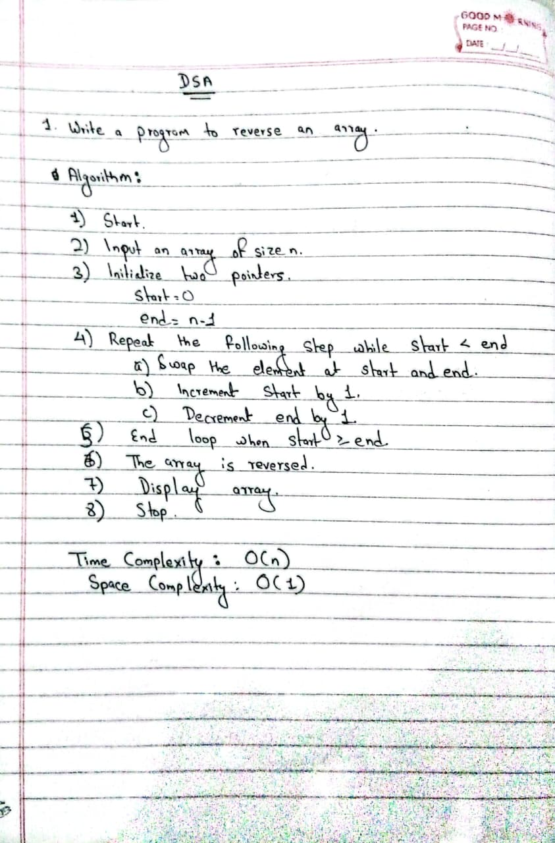
public class ReverseArray {
public static void main(String[] args) {
int[] arr = {1, 2, 3, 4, 5};

// Reverse the array
int start = 0;
int end = arr.length - 1;
while (start < end) {
// Swap elements
int temp = arr[start];
arr[start] = arr[end];
arr[end] = temp;

start++;
end--;
}

System.out.println("\nReversed Array:");
for (int num : arr) {
System.out.print(num + " ");
}
}
}
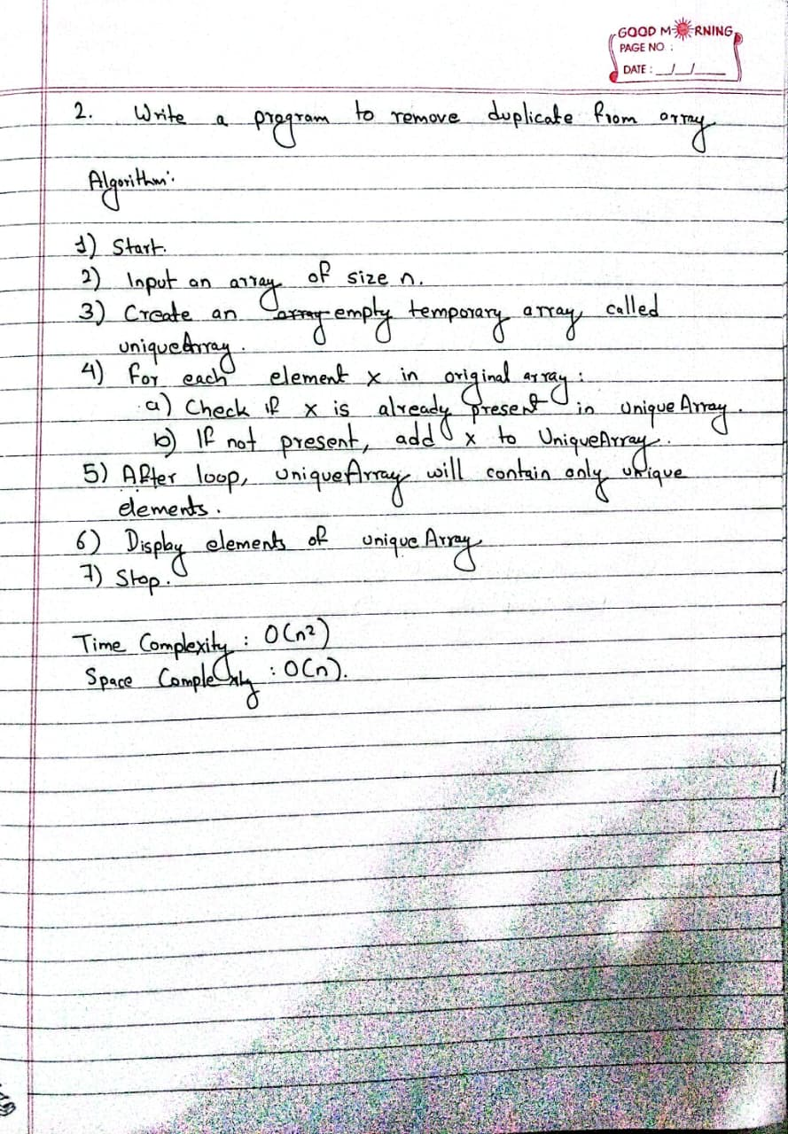
public class RemoveDuplicatesArray {
public static void main(String[] args) {
int[] arr = {1, 2, 3, 2, 4, 1, 5, 3};
int n = arr.length;

int[] temp = new int[n];
int uniqueCount = 0;

for (int i = 0; i < n; i++) {
boolean isDuplicate = false;

// Check if arr[i] already exists in temp
for (int j = 0; j < uniqueCount; j++) {
if (arr[i] == temp[j]) {
isDuplicate = true;
break;
}
}

// If not duplicate, add it to temp
if (!isDuplicate) {
temp[uniqueCount] = arr[i];
uniqueCount++;
}
}
// Print array without duplicates
for (int i = 0; i < uniqueCount; i++) {
System.out.print(temp[i] + " ");
}
}

}
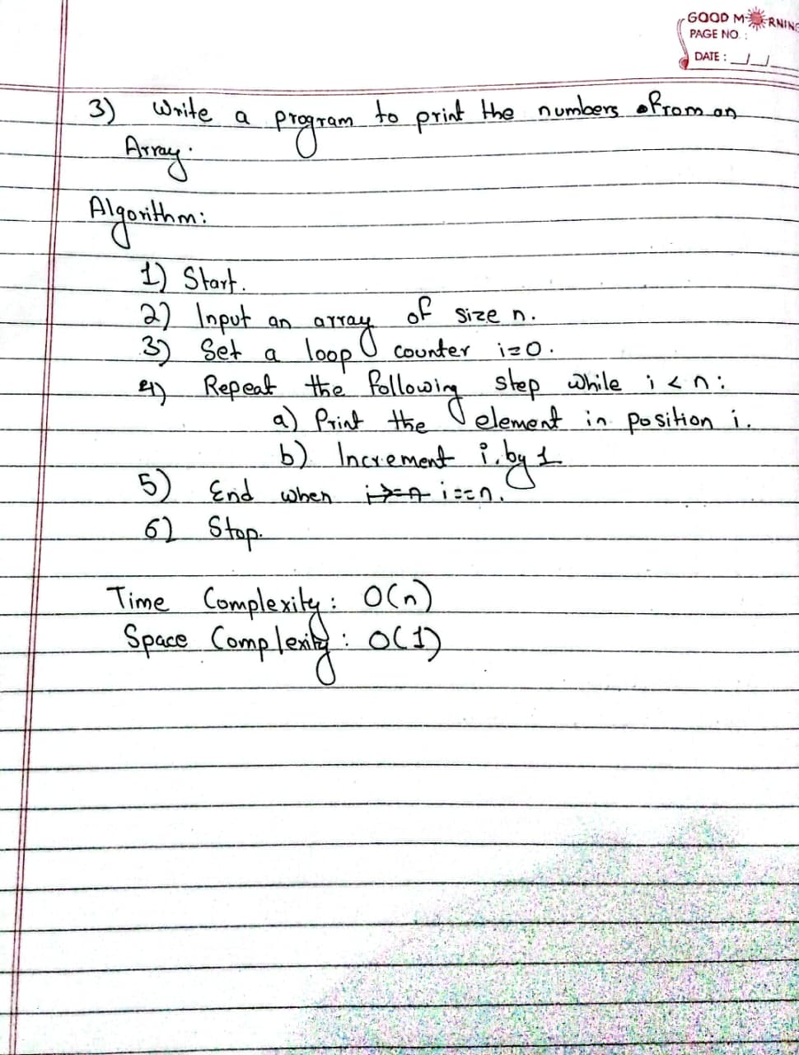
public class PrintArray {
public static void main(String[] args) {
int[] arr = {10, 20, 30, 40, 50};

for (int i = 0; i < arr.length; i++) {
System.out.println(arr[i]);
}
}
}

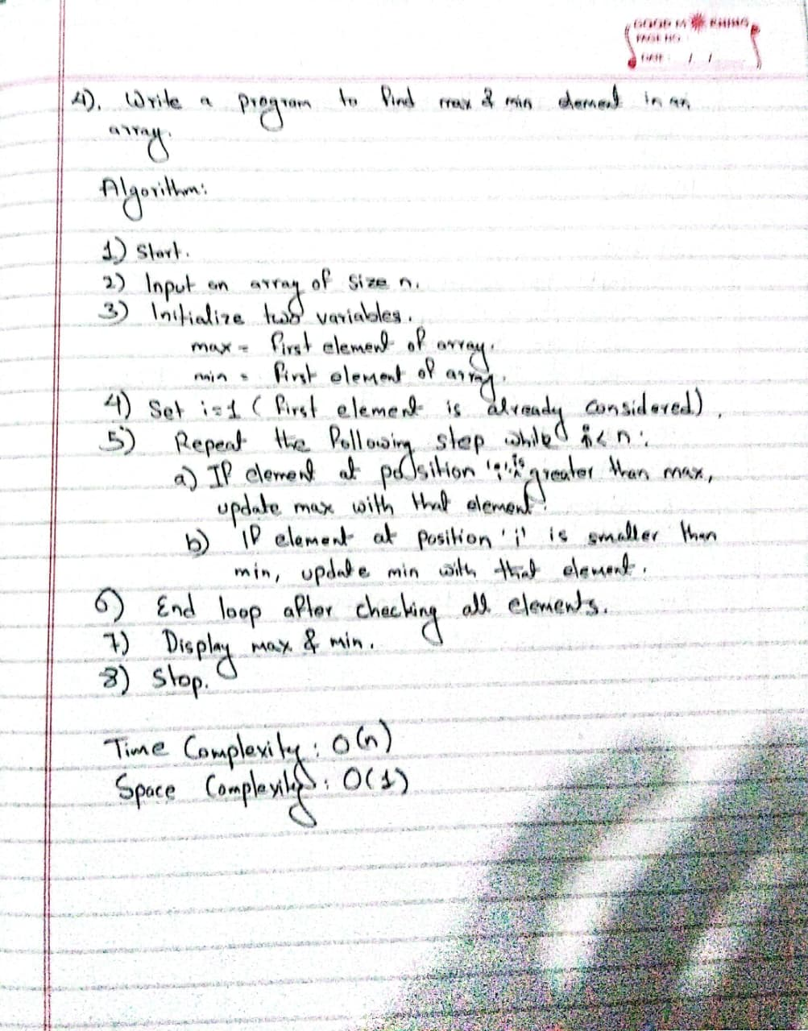
public class MaxMinArray {
public static void main(String[] args) {
int[] arr = {5, 12, 7, 25, 3, 18};

int max = arr[0];
int min = arr[0];

// Loop through the array
for (int i = 1; i < arr.length; i++) {
if (arr[i] > max) {
max = arr[i];
}
if (arr[i] < min) {
min = arr[i];
}
}

System.out.println("Maximum element: " + max);
System.out.println("Minimum element: " + min);
}
}

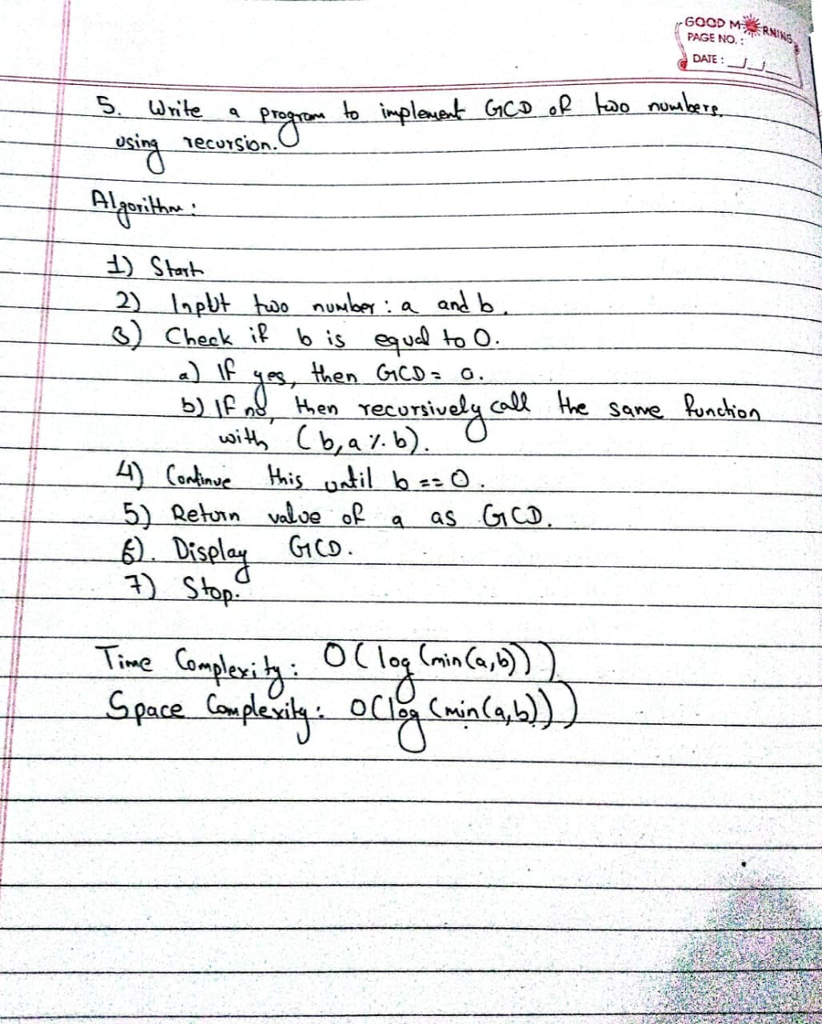
public class GCDRecursion {
// Recursive method to find GCD
static int gcd(int a, int b) {
if (b == 0) return a;
else return gcd(b, a % b);
}

public static void main(String[] args) {
int num1 = 48;
int num2 = 18;

int result = gcd(num1, num2);

System.out.println("GCD: " + result);
}

}
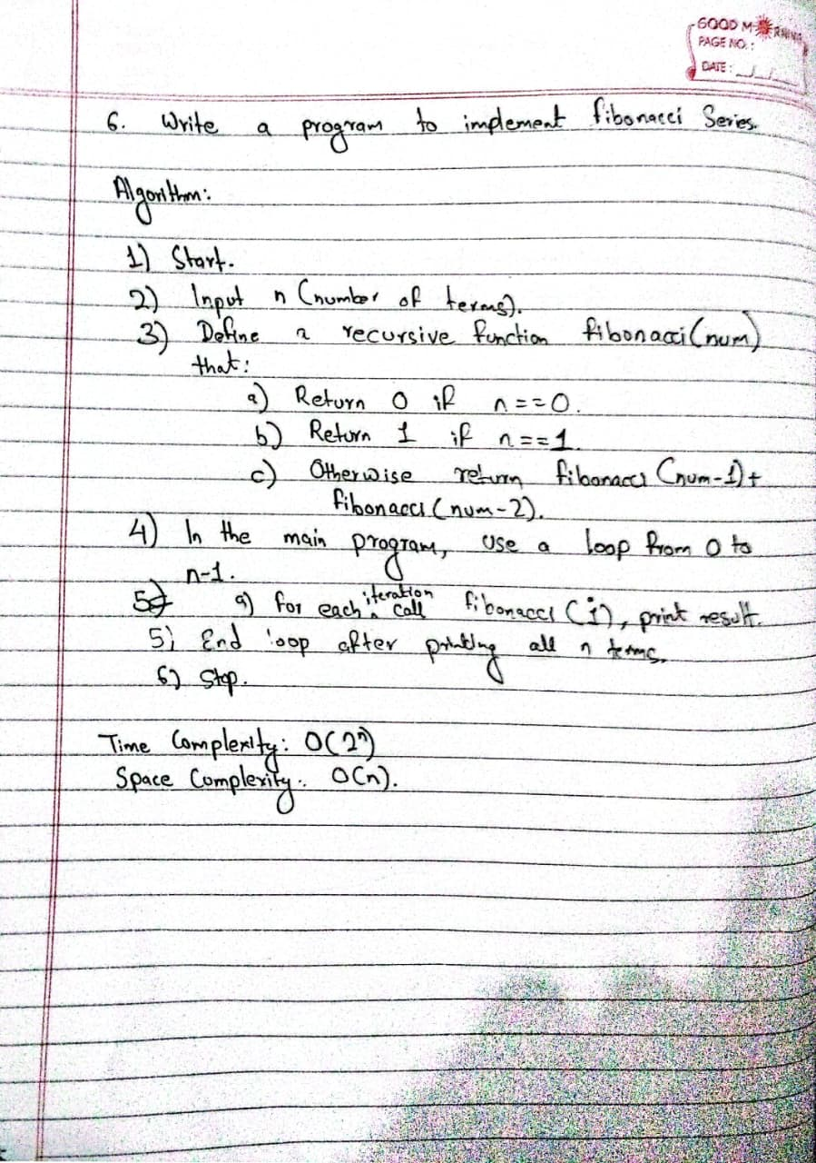

public class Fibonacci {
public int Fib(int term) {
return switch (term) {
case 0 -> 0;
case 1 -> 1;
default -> Fib(term-1) + Fib(term-2);
};
}

public static void main(String[] args) {
int term = 10;
Fibonacci fib = new Fibonacci();
for (int i = 0; i < term; i++) {
System.out.println(fib.Fib(i));
}
}
}

Github Repository: https://www.github.com/Sachin-Timilsina/DSA-Assignments.git

